Software Design Document
Online Shopping System



Submitted by
Muhammad Adnan (S25BINFT7M04008)
Submitted To : Syed Ali Nawaz Shah

Department of Information Technology
Faculty of Computing
The Islamia University of Bahawalpur

Summary
The Software Design Document (SDD) for the Online Shopping System presents the architectural and detailed design of a personalized e-commerce platform that aims to solve one of the biggest challenges in online clothing shopping: finding the right fit. Traditional online shopping often relies on size charts and measurements, which can be confusing and lead to frequent product returns. To address this issue, the proposed system introduces the innovative 15-Second Fit Quiz, a feature that focuses on body geometry and personal style preferences rather than complex measurements.
The system is designed to provide a highly personalized shopping experience by identifying a user’s body shape and recommending clothing items that best suit their physique. By integrating body-shape-aware technology, the platform goes beyond standard e-commerce functionality and creates a customized storefront where products are filtered and recommended according to individual user characteristics. In addition to personalized recommendations, the system includes essential e-commerce features such as secure payment processing, inventory management, order tracking, and user profile management.
The platform serves three primary user groups: Practical Shoppers who seek convenience and accurate recommendations, Style Enthusiasts who want fashion suggestions tailored to their body type, and Administrators who analyze user trends and manage products and inventory. Unlike many existing systems that require detailed measurements, this platform uses a fast heuristic-based approach that improves user engagement while maintaining recommendation accuracy.
From a technical perspective, the system is built using modern technologies such as React.js or Flutter for the frontend, Node.js or Python for backend processing, and PostgreSQL for data management. The design emphasizes scalability, maintainability, security, and performance. The core recommendation functionality is supported by a decision-based algorithm that processes responses from the Fit Quiz and generates personalized product suggestions. Furthermore, all sensitive user data is protected using AES-256 encryption, and the recommendation process is optimized to deliver results within seconds, ensuring a smooth and efficient shopping experience.
Overall, this Software Design Document provides a comprehensive blueprint for the implementation of a secure, scalable, and intelligent online shopping platform that enhances customer satisfaction through personalized clothing recommendations and an improved online shopping experience.

Table of Contents
1.Introduction ........................................................................................................ 04
1.1 Purpose .......................................................................................................... 04
1.2 Scope ............................................................................................................. 04
1.3 System Perspective ......................................................................................... 04
1.4 Design Considerations .................................................................................... 05
1.5 Proposed Technologies ................................................................................... 05
2.System Design ..................................................................................................... 06
2.1 Architectural Design ....................................................................................... 06
2.2 Database Design ............................................................................................ 06
2.3 Module Design ............................................................................................... 07
2.4 Interface Design ............................................................................................. 07
3.Use Cases and Flow of Processes ....................................................................... 08
3.1 Use Case 1: Finding the Perfect Fit ................................................................. 08
4.References ........................................................................................................... 09

1. Introduction
The Online Shopping System is a modern e-commerce platform designed to improve the online clothing shopping experience through personalized recommendations and intelligent product filtering. One of the major challenges faced by online shoppers is selecting the correct clothing size and style without physically trying the product. This often results in customer dissatisfaction and a high number of product returns. To address this issue, the proposed system introduces an innovative feature called the 15-Second Fit Quiz, which analyzes a user's body shape and style preferences to provide personalized clothing recommendations.
The system combines traditional e-commerce functionalities such as user registration, product browsing, shopping cart management, secure payments, and order tracking with advanced personalization features. The goal is to create a smart shopping environment where users can quickly find clothing items that best suit their body type and fashion preferences.
1.1 Purpose
The purpose of this Software Design Document (SDD) is to describe the overall architecture, design components, modules, interfaces, database structure, and workflows of the Online Shopping System. This document serves as a technical blueprint for developers, testers, project managers, and stakeholders involved in the development process.
The document provides a detailed explanation of how the system components interact with each other and how various modules work together to deliver a personalized shopping experience. It also ensures that all stakeholders have a common understanding of the system design before implementation begins.
The specific objectives of this document are:
• Define the architectural design of the system.
• Describe software modules and their responsibilities.
• Explain database structures and relationships.
• Provide interface and workflow descriptions.
• Define security and performance considerations.
• Guide future maintenance and enhancements.
1.2 Scope
The Online Shopping System is designed as a web and mobile-based application that allows users to browse products, receive personalized recommendations, purchase clothing items, and track orders.
The scope of the system includes:

User Features
• User Registration and Login
• Profile Management
• 15-Second Fit Quiz
• Product Search and Filtering
• Personalized Recommendations
• Shopping Cart Management
• Secure Checkout Process
• Order Tracking
• Product Reviews and Ratings
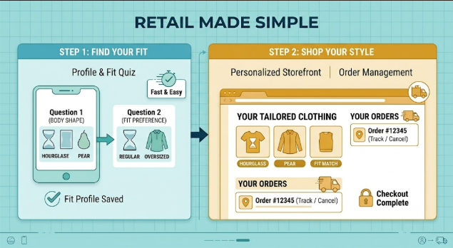
Administrator Features
• Product Management
• Inventory Management
• User Management
• Order Monitoring
• Sales Reports
• Recommendation Analytics
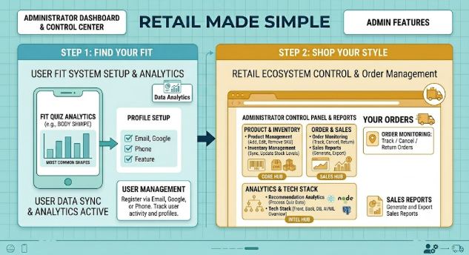
System Features
• Real-Time Inventory Updates
• Personalized Product Suggestions
• Secure Payment Processing
• Data Encryption
• Performance Monitoring
The system focuses primarily on clothing products and fashion-related recommendations based on body shape analysis and style preferences.

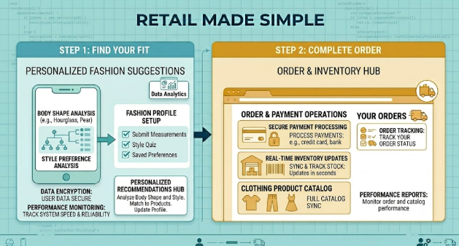
1.3 System Perspective
The Online Shopping System operates as a standalone e-commerce platform that integrates multiple software components to provide seamless shopping experiences.
The system follows a Three-Tier Architecture consisting of:
1. Presentation Layer (Frontend)
This layer provides the graphical user interface through which users interact with the system.
Responsibilities:
• Display product catalogs.
• Show personalized recommendations.
• Collect user input.
• Manage shopping cart operations.
Technologies:
• React.js
• Flutter
2. Business Logic Layer (Backend)
This layer processes user requests and performs business operations.
Responsibilities:
• User authentication.
• Product management.
• Recommendation generation.
• Order processing.
• Payment handling.
Technologies:
• Node.js
• Django (Python)

3. Data Layer (Database)
This layer stores and manages application data.
Responsibilities:
• User information.
• Product details.
• Orders.
• Quiz results.
• Recommendation history.
Technology:
• PostgreSQL
External Systems
The Online Shopping System communicates with:
• Payment Gateway Services
• Inventory Management Systems
• Email Notification Services
• SMS Verification Services
These integrations ensure smooth business operations and secure transactions.
1.4 Design Considerations
Several important factors were considered while designing the system.
1. Scalability
The system should support thousands of concurrent users and products without performance degradation. The architecture allows future expansion through cloud deployment and distributed services.
2. Maintainability
The software is divided into independent modules to simplify maintenance and future updates. Developers can modify one module without affecting the entire system.
3. Security
User information and body metrics are sensitive data. Therefore, strong encryption and secure authentication mechanisms are implemented.
Security measures include:
• AES-256 Encryption
• Secure Password Hashing
• HTTPS Communication
• Role-Based Access Control
4. Performance
Users expect fast responses while browsing products and receiving recommendations. Therefore, optimized database queries and caching mechanisms are used.
Performance Goals:
• Quiz processing within 2 seconds.
• Product page loading within 3 seconds.
• Fast search results.
5. Usability
The interface is designed to be simple and intuitive. The Fit Quiz should be completed within 15 seconds to maintain user engagement.
6. Reliability
The system should remain available even during peak shopping periods and must prevent data loss through backup mechanisms.
Frontend Technologies
- React.js
- React.js is a JavaScript library used for developing dynamic and responsive web interfaces.
Advantages:
• Fast rendering.
• Component-based architecture.
• Reusable UI components.

Flutter
Flutter is used for mobile application development.
Advantages:
• Single codebase.
• High performance.
• Native-like user experience.
Backend Technologies
Node.js
Node.js provides fast and scalable server-side processing.
Advantages:
• Event-driven architecture.
• High performance.
• Supports real-time operations.
2. System Design
System Design describes how different software components work together to achieve system objectives. It provides a blueprint for implementation and explains the overall structure of the Online Shopping System.
The design includes architecture, database structure, modules, and user interfaces.

2.1 Architectural Design
The system follows a Three-Tier Architecture.
Layer 1: Presentation Layer
Contains:
• User Interface
• Product Pages
• Cart Pages
• Quiz Screens
• Admin Dashboard

Layer 2: Application Layer
Contains:
• Authentication Services
• Recommendation Engine
• Order Processing Services
• Product Management Services
Layer 3: Data Layer
Contains:
• User Database
• Product Database
• Order Database
• Recommendation Database
This architecture improves scalability, maintainability, and security.
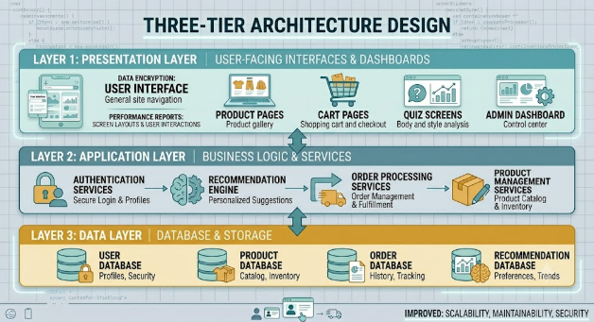
2.2 Database Design
The database stores all information required by the system.
Main Tables
User Table
Stores:
• User ID
• Name
• Email
• Password
• Quiz Results
Product Table
Stores:
• Product ID
• Name
• Category
• Price
• Size
• Stock Quantity
Order Table
Stores:
• Order ID
• User ID
• Product ID
• Payment Status
• Order Status
Recommendation Table
Stores:
• Quiz Results
• Body Shape
• Recommended Products
Relationships are maintained using primary and foreign keys to ensure data integrity.

2.3 Module Design
The system consists of several modules.
User Management Module
Handles:
• Registration
• Login
• Profile Management
Fit Quiz Module
Handles:
• Quiz Questions
• Shape Analysis
• Preference Collection
Recommendation Module
Generates personalized product suggestions based on quiz responses.
Product Management Module
Handles:
• Product Creation
• Product Updates
• Inventory Control
Order Management Module
Handles:
• Order Placement
• Order Tracking
• Returns
Administration Module
Allows administrators to manage users, products, and reports.

2.4 Interface Design
The user interface is designed to be simple and user-friendly.
Main Screens
• Login Screen
• Registration Screen
• Home Screen
• Fit Quiz Screen
• Product Catalog Screen
• Shopping Cart Screen
• Checkout Screen
• Order Tracking Screen
• Admin Dashboard
The interface follows responsive design principles to support desktop, tablet, and mobile devices.

3. Use Cases and Flow of Processes
This section describes how users interact with the system and how processes flow between different modules.

3.1 Use Case 1: Finding the Perfect Fit
Actor
Registered User
Precondition
User must be logged into the system.
Main Flow
Step 1:
User selects "Take the 15-Second Fit Quiz."
Step 2:
System displays visual body shape options.
Step 3:
User selects body shape and style preference.
Step 4:
System processes responses.
Step 5:
Recommendation Engine analyzes results.
Step 6:
Personalized products are displayed.
Step 7:
User browses recommended products.
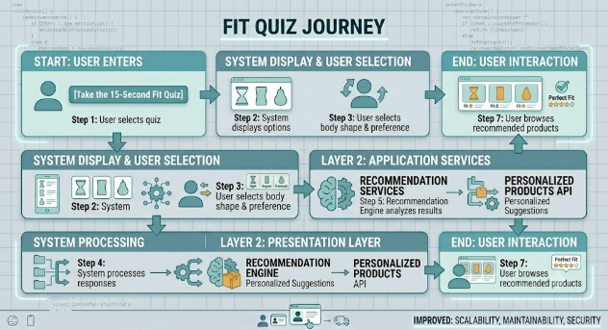

Postcondition
The user receives personalized clothing recommendations that match their body shape and preferences.

Benefits
• Improved shopping experience.
• Reduced return rates.
• Faster product discovery.
• Increased customer satisfaction.

4. References
- IEEE Std 1016 – Software Design Description Standard.
- IEEE Std 830 – Software Requirements Specification.
- Analysis of E-Commerce Personalization Algorithms.
- UI/UX Design Patterns for Rapid User Input.
- PostgreSQL Official Documentation.
- React.js Official Documentation.
- Flutter Official Documentation.
- Node.js Official Documentation.
- Django Official Documentation.

